MUSIO DYNAMIC APP
USER GUIDE

NOTE: Musio can be controlled from android app or from voice. If we control him from phone, then voice command will not work. So if we want to control him by voice, please disconnect from app by turn of the app or turn off bluetooth.

Step 0: install app from apk file

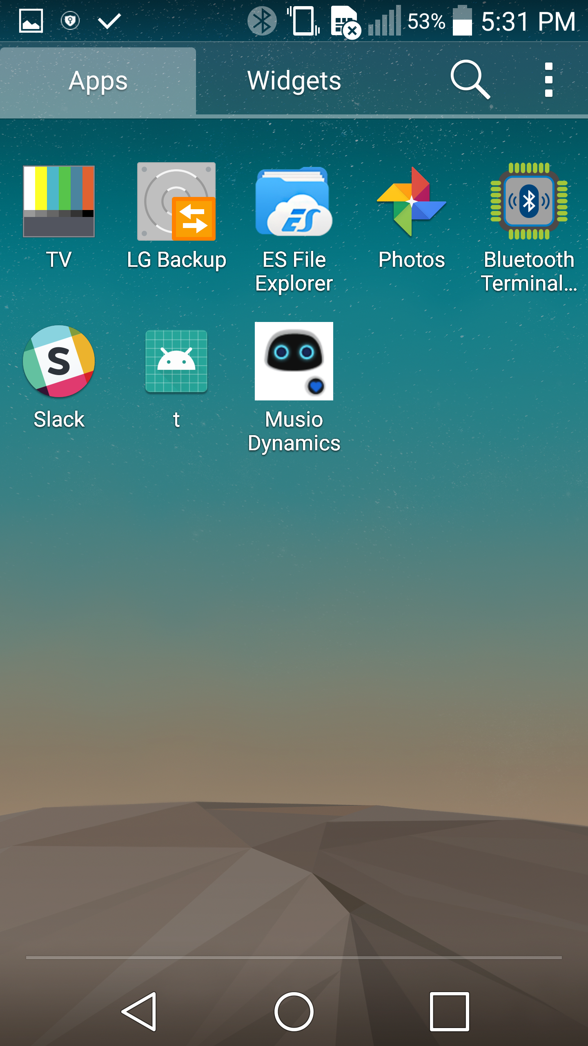
- coppy apk file to phone and run that file by ES File Explorer or any other app

Result is trying to get the icon as in picture

Here below is how to settup and control musio from android app

Step 1: turn on bluetooth and pair to Musio
open the setting on phone and turn on bluetooth to search for musio dynamic

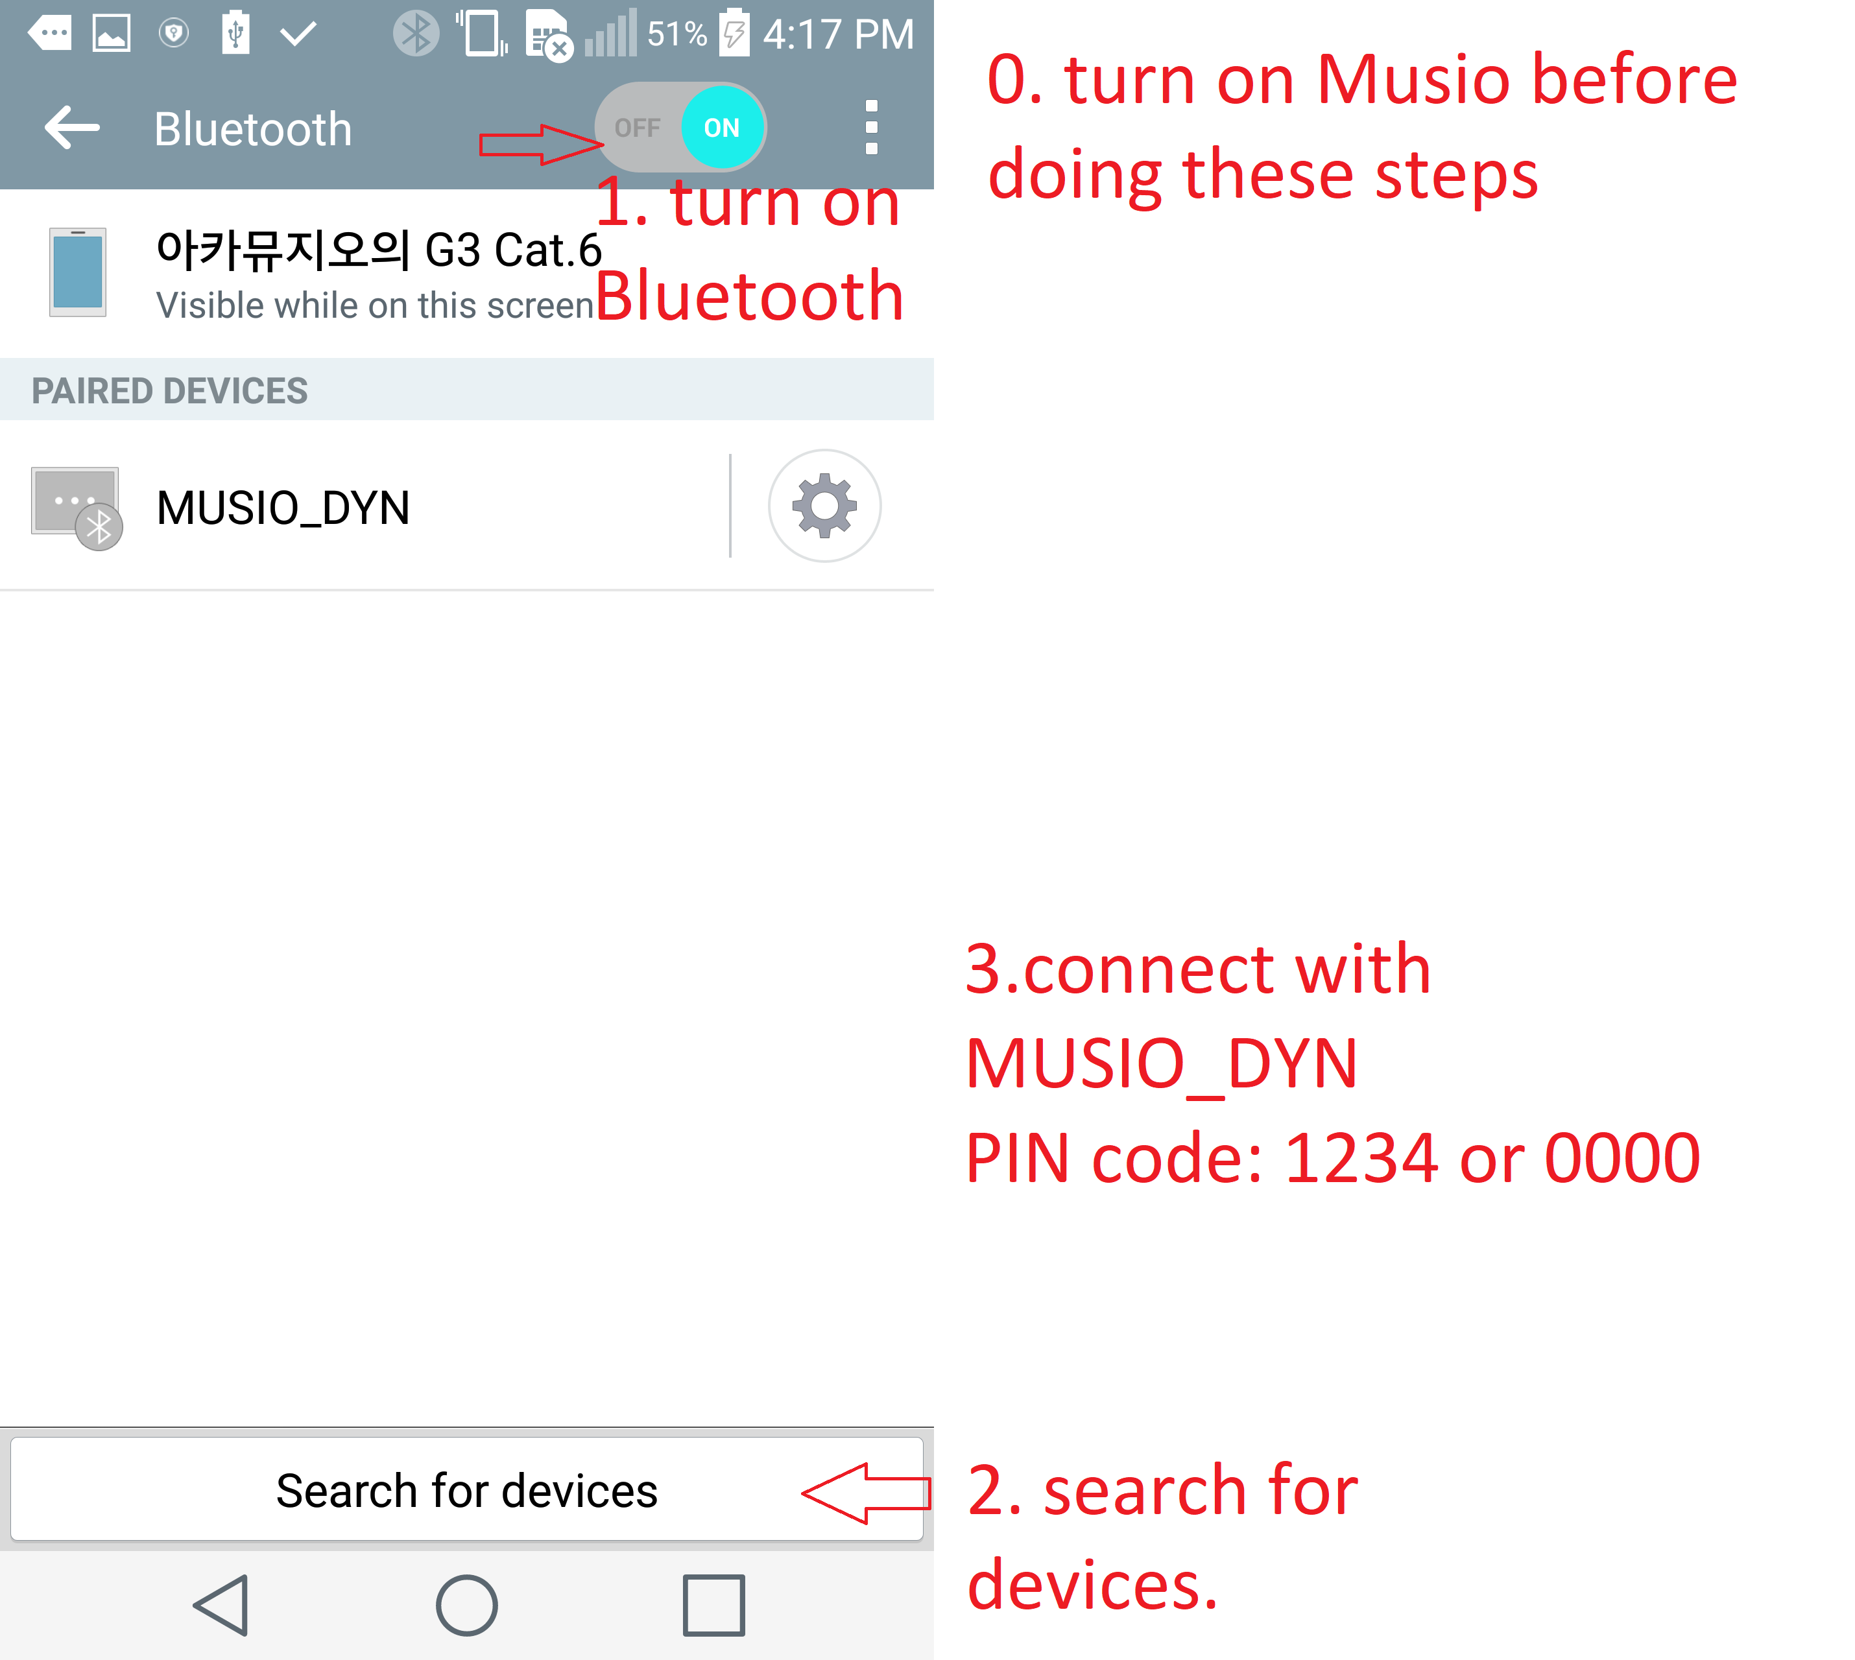

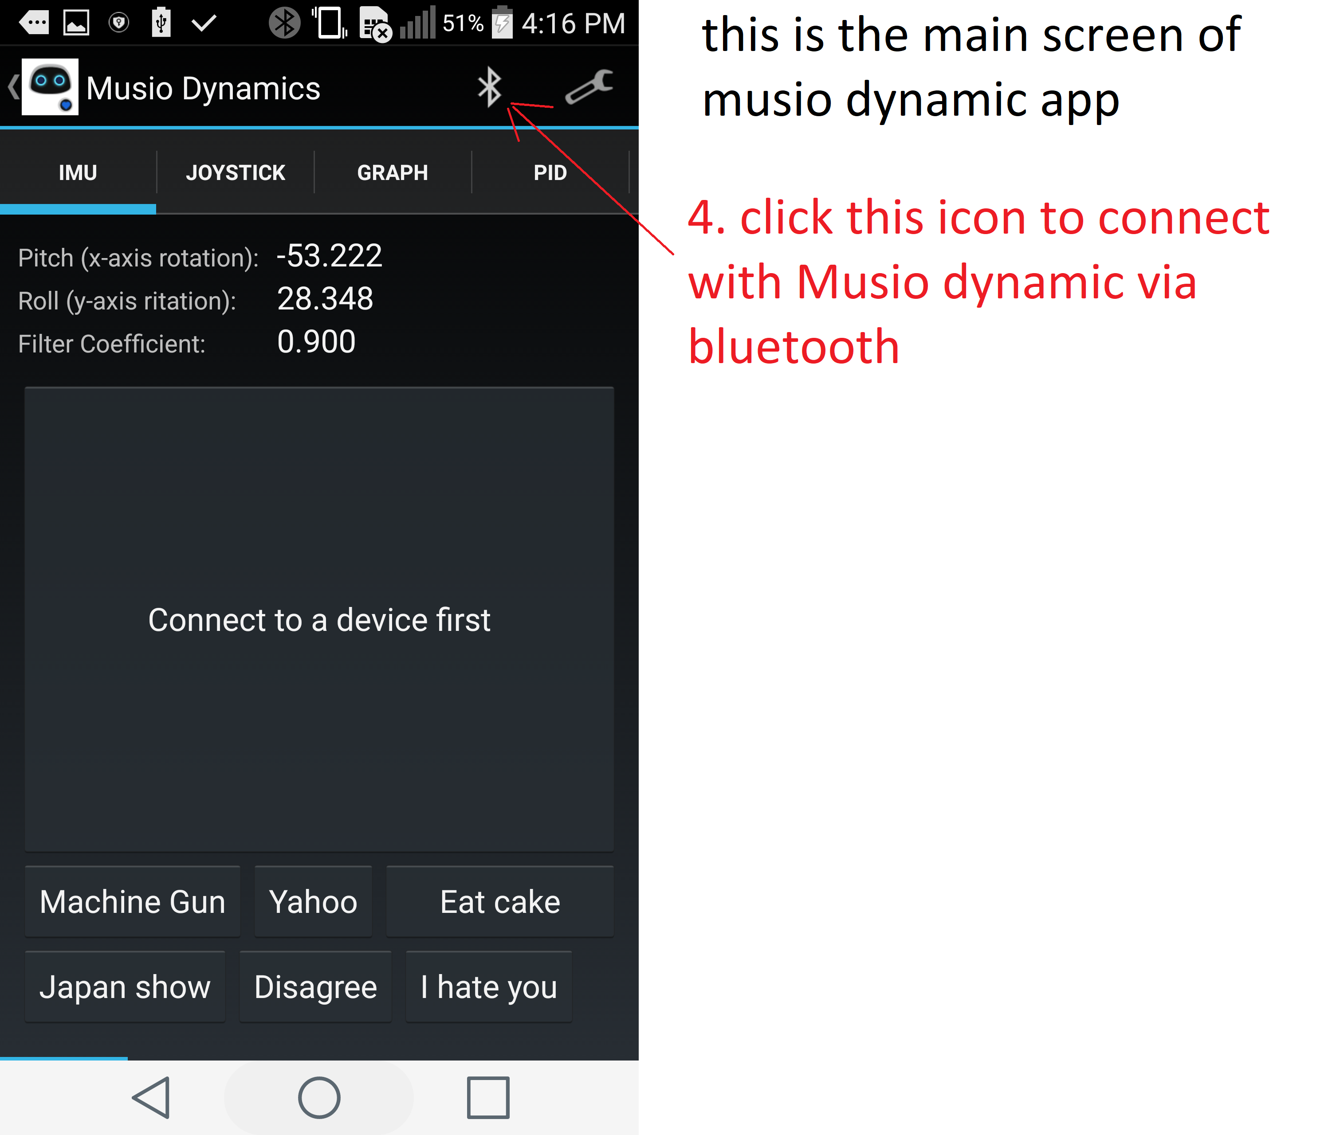
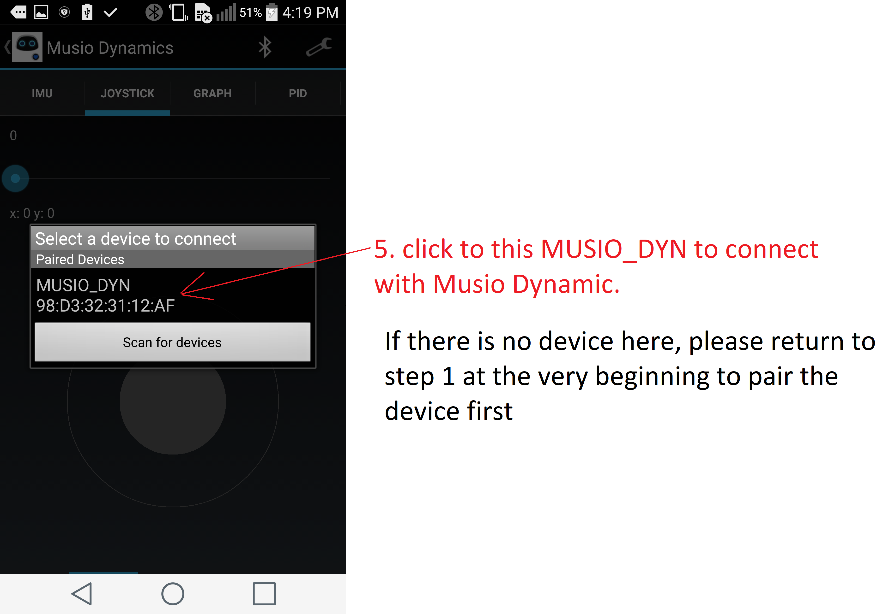
Step 2: turn on app and connect with musio
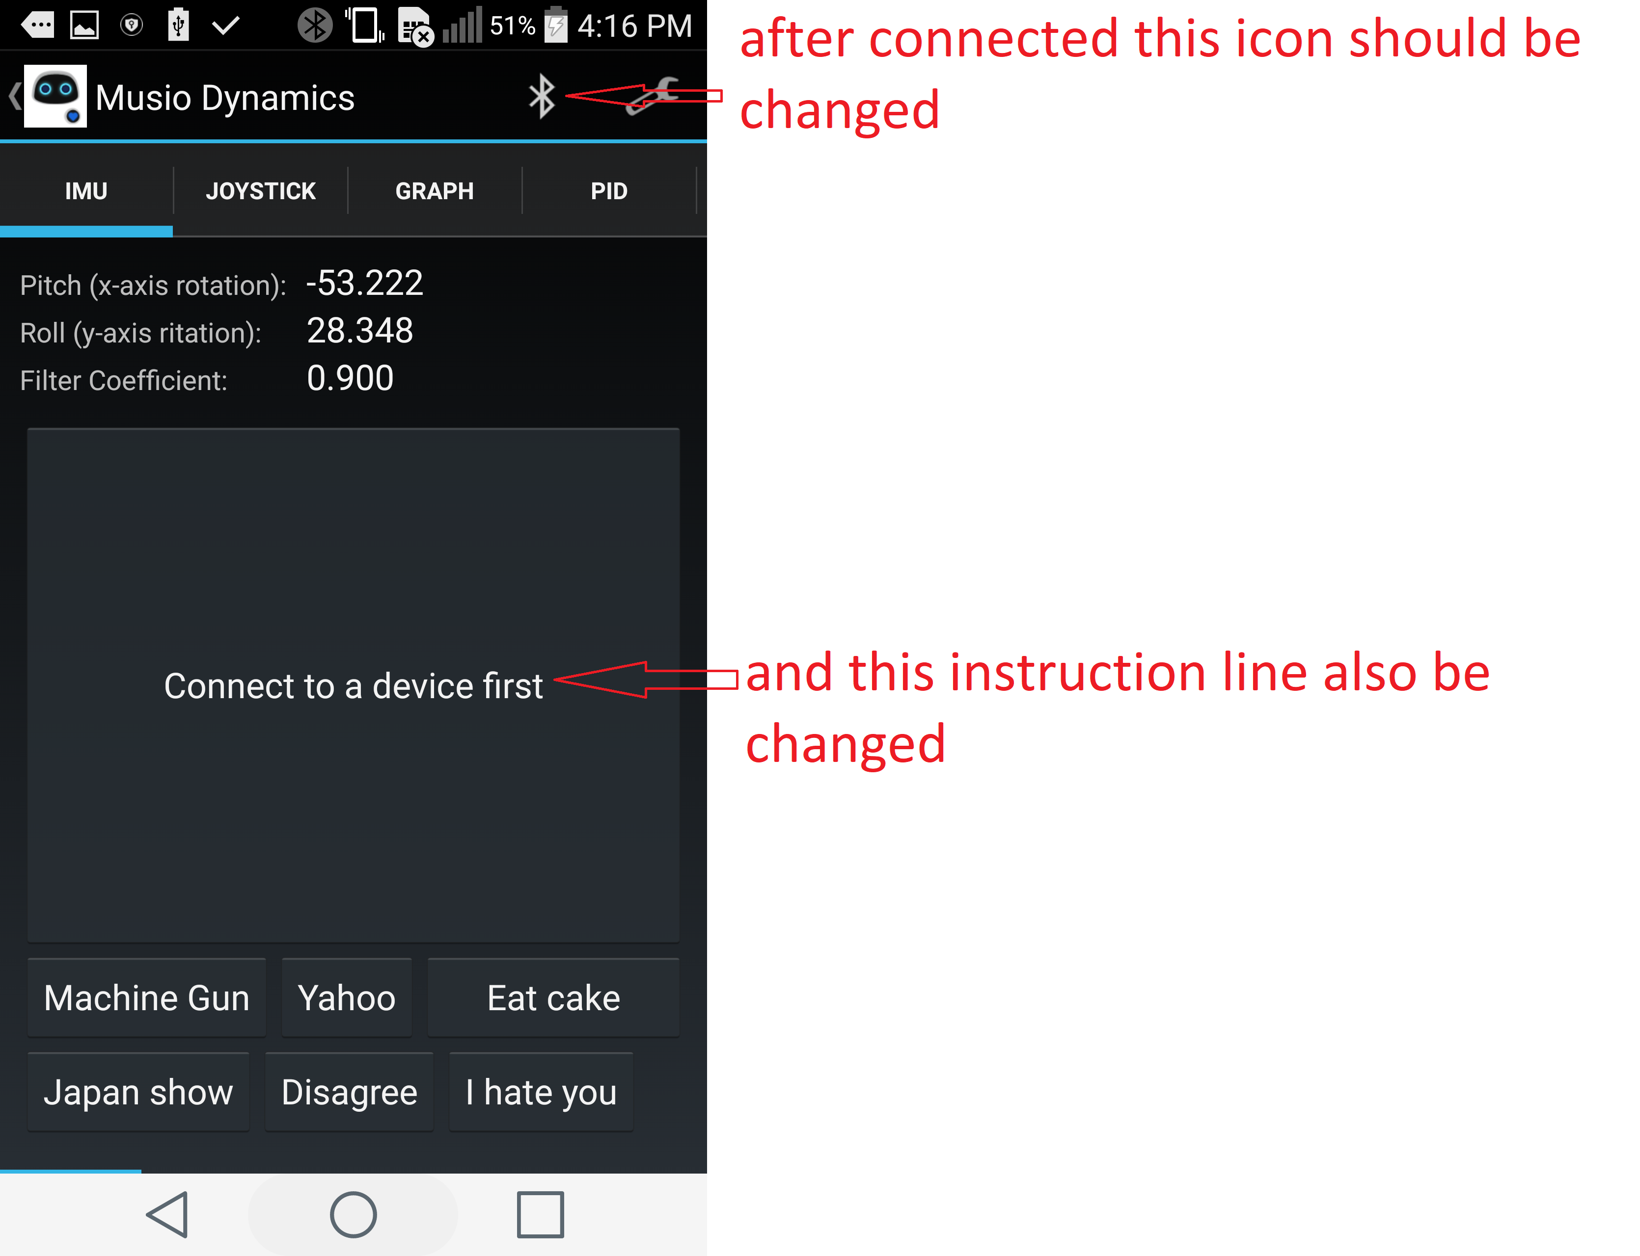
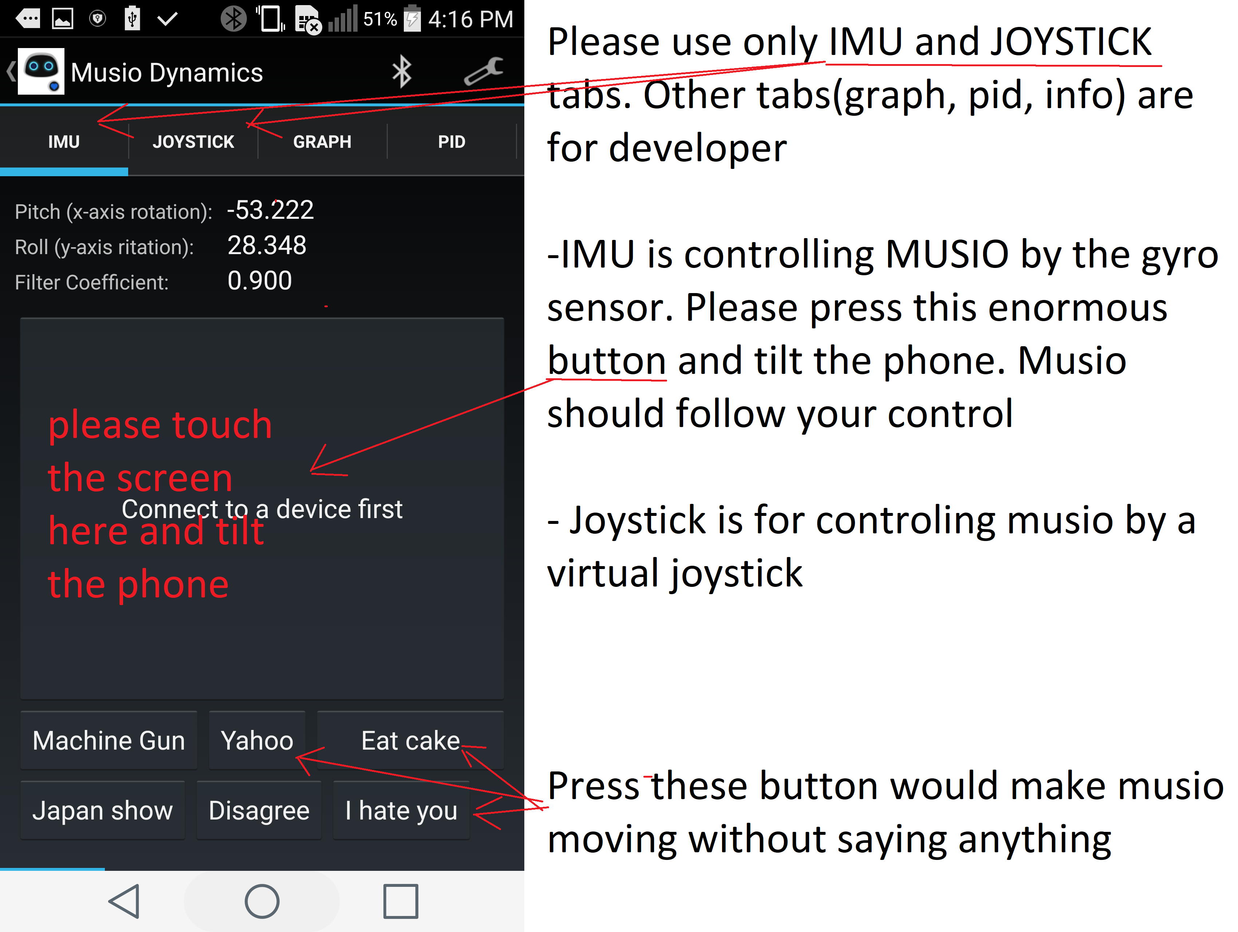
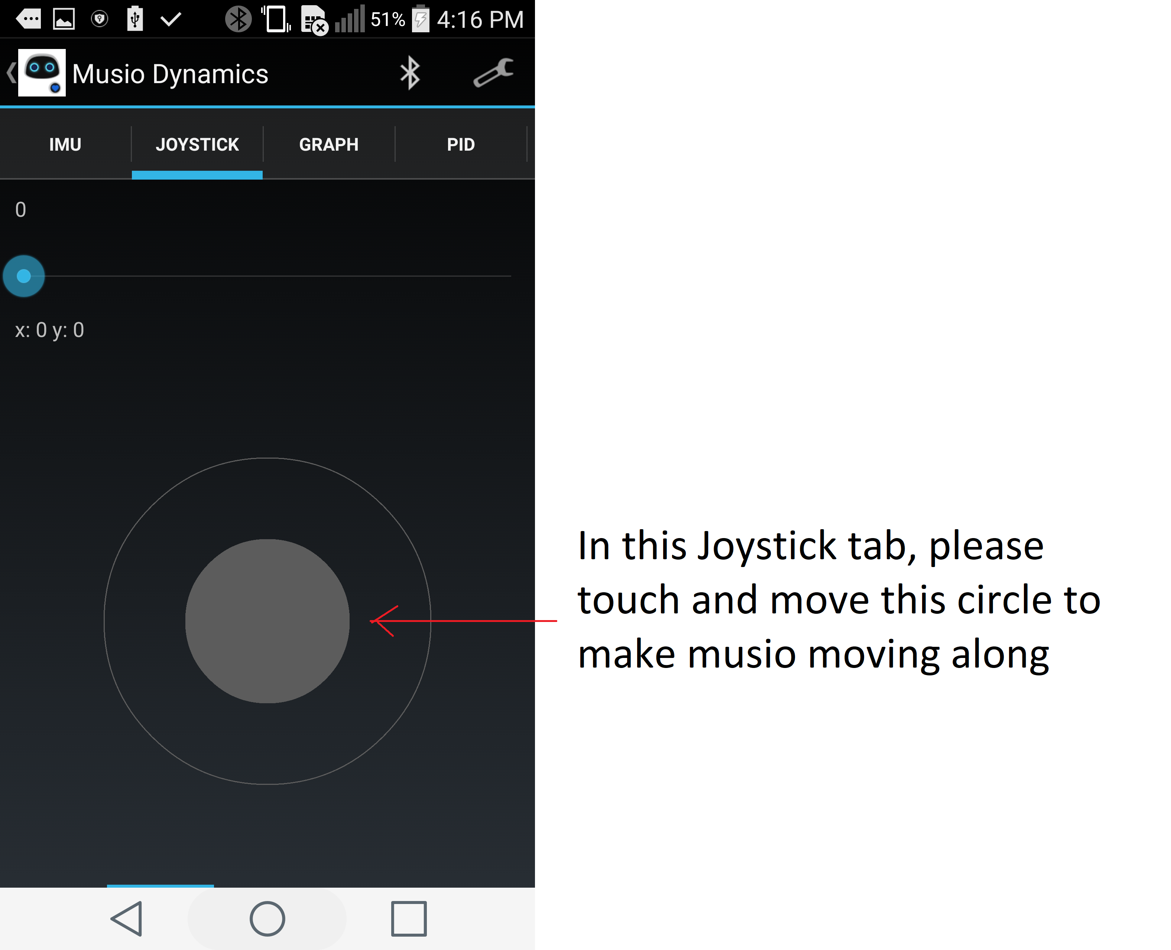

Last note: Please disconnect musio and phone before controling musio by voice.

Please contact Tony via Slack or tony.ngo@akaon.com if this guide is not that clear.
Thank you and have a nice day <3

